MACHINERY

ILLUSTRATION

AUTOMATIC CARTON ERECTOR

MODEL: CE-12
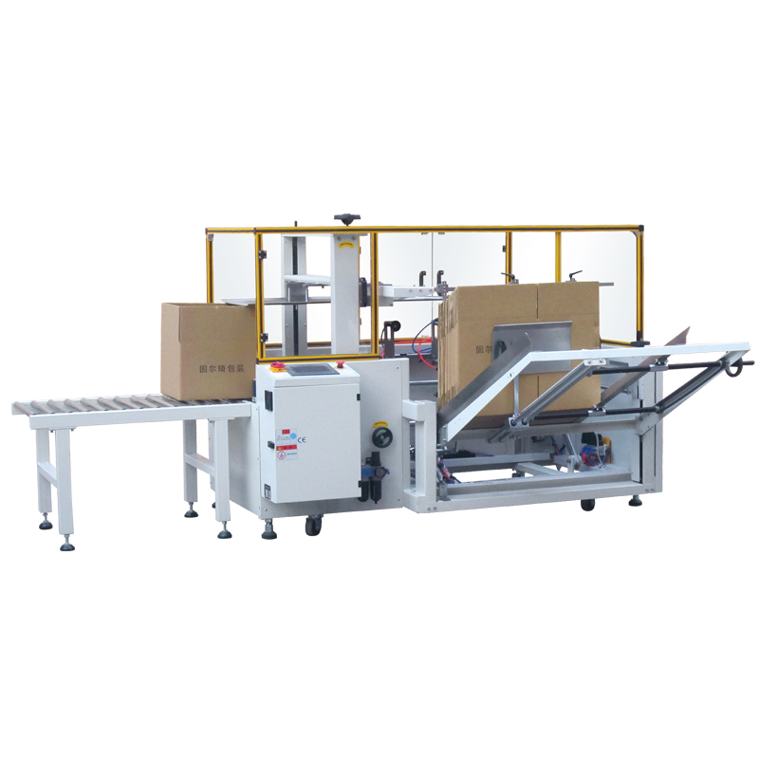
Cleveland Equipment & Machinery Company
PREFACE

Thank you for purchasing the auto carton sealer.
This manual will show you the basic structure, using method and points for attention to use this machine safely and correctly. Please read this manual carefully before operating the machine. Be sure that the manual is hand to the final users. This manual content change, without prior notice.
GPA carton sealer series use OPP tape to seal different kinds of cartons. The machine is operated and maintained easily with simple structure and high quality, for which it is widely used in various industries.

SAFETY INFORMATION
- The operator should read the operating manual carefully before operating this machine.
- The operator can not touch any driving parts before running this machine.
- The maintenance personnel should read the operating manual carefully before maintaining this machine.
- The power and gas must be closed when installing the tape and doing the daily maintenance.
- Only the trained personnel can operate the machine.

CONTENTS

1 Specification.....................................................................................4
2 Machine structure and adjustment instruction………………....5
3Operation flow……..………………………………….…………...6
3.1 Operating instruction of the machine parts…………..…….....6
3.2 Electrical control operation explaination………..…………....11
3.3 Pneumatic Parts Instruction………………….…… …..…16
3.4 Tape Head’s operating and Maintainance……………………19
4 Exploded figure……………………………………………..…....23
4.1 Each device figure of main body………….…………………...23
4.2 Main machine frame and electric cabinet figure……...……...24
4.3 Store chute device figure…………………………….………….25
4.4 Rear cover folding and carton pushing device figure…………27
4.5 Carton fetching device figure……………………………..…….28
4.6 Adjusting device figure………………………………………….30
4.7 Side Flaps Folding Device………………….……………………31
4.8 Front flap folding and taping part…………………………...…32
4.9 Tape Head Part………………………………………..…………33
4.10 Belts conveying device……………………………...…………...35

1 Specification
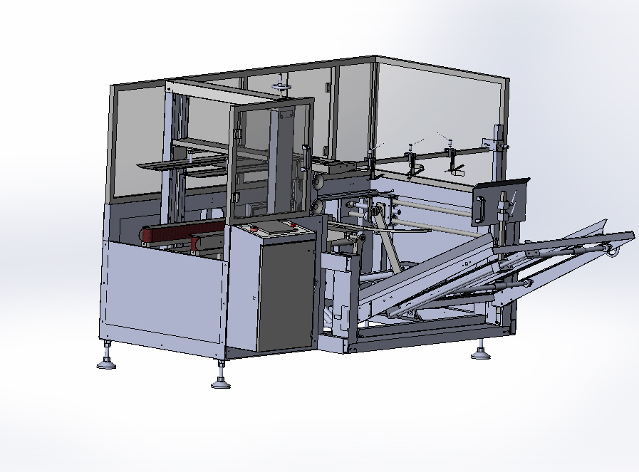
The carton erector is a Semi-auto carton sealing machine which can fold the bottom cover of carton and seal; it can be operated separately, economic and high-efficiency, which is an ideal packaging machine. The main parameters are listed as follows:
Sealing speed：12ctns/min
Sealing width：150mm~400mm
Sealing height：100mm~400mm
Sealing lenght：250mm~450mm
Machine dimension：L2000 mm ×W1900 mm ×H1450 mm
Power supply：220v 1φ 200W
Air pressure：6kg/cm²
Applicable tape：W（48、60、72）mm×L1000y
Machine weight：450kg
2. Machine structure and adjustment instruction（P.1）：
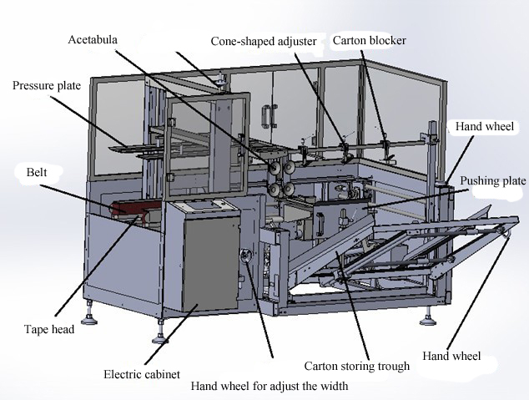
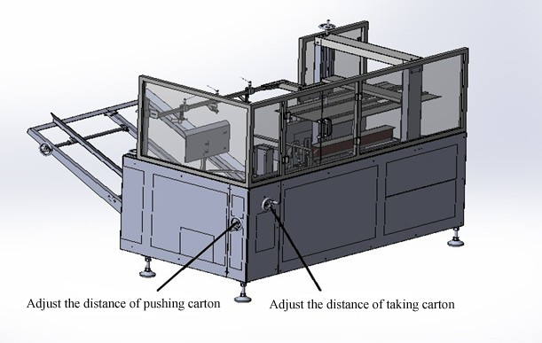
P.1

3. Operation flow
3.1 Operating instruction of the machine parts
1）Take out a formed carton
2）Turn the tape width adjusting hand wheel (clockwise, width of belt narrows, anticlockwise, width of belt widens), make the width the same with the carton width.( P.2)
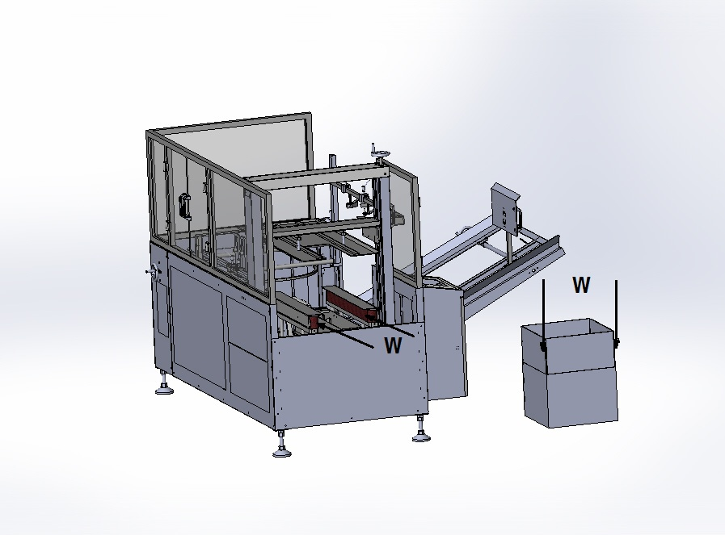
P.2
3）Turn the adjusting hand wheel of the carton fetching system and make the acetabula surface is parallel with the strap surface when the acetabula is in the high-point.( P.3)
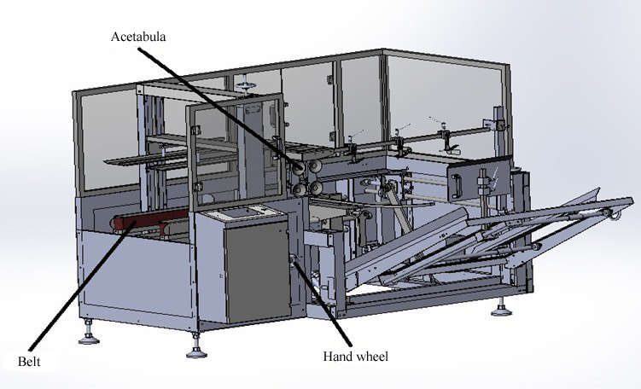
P.3
4） Take out an unformed carton, put it onto the lower brim of the carton blocker, and then adjust the height and width of the carton storing trough, to make it the same as the unformed carton’s height and width.( P.4)
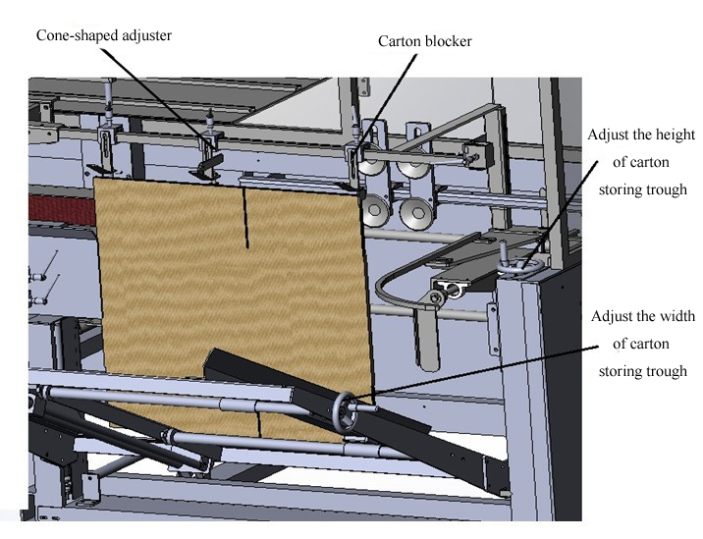
P.4
5) Adjust the cone-shaped adjuster，to make it align the carton folding line. (P.5)
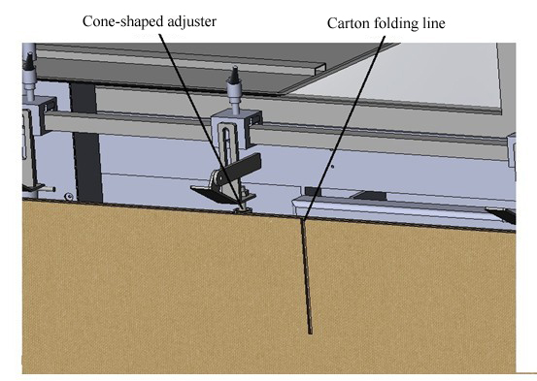
P.5
6）Turn the carton pushing adjust hand wheel to make the carton pushing pole, cone-shaped adjuster and the carton folding line in line. (P.6)
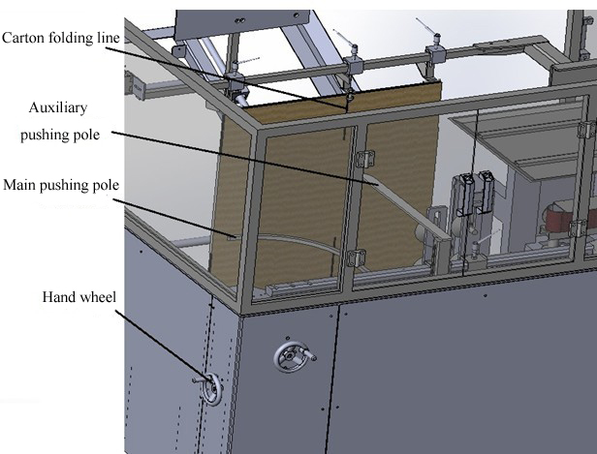
P.6
7）Adjust the acetabula to right position based the size of the carton . (P.7)

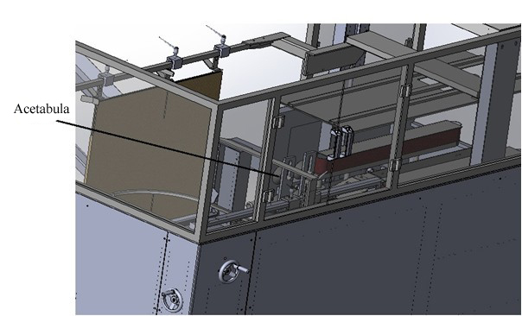
P.7
8）Finally put the unformed cartons into the carton storing trough, then lay down the pushing plate. (P.8)

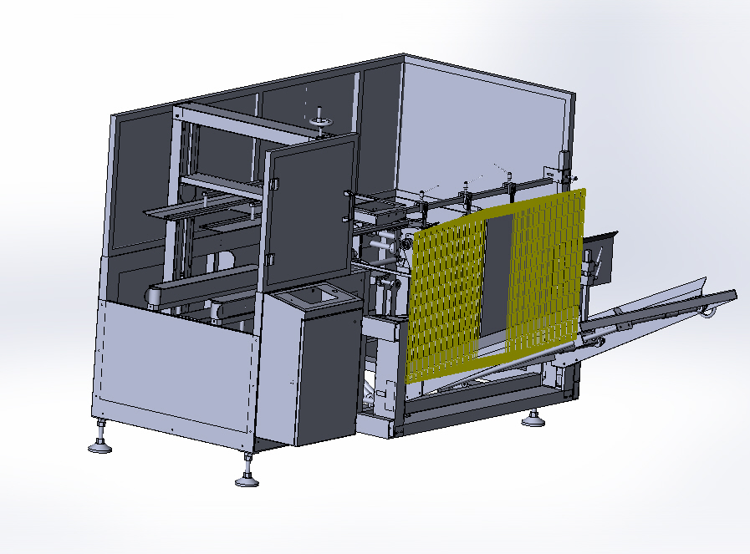
P.8
3.2 Electrical control operation explaination
1）Make sure the machine is connected to the power supply and gas sources.
2）Start the NFB, start button by order, and make sure the emergence button is unpressed. (P.9)
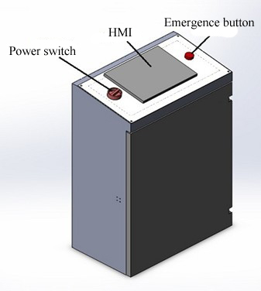
P.9
3）After the machine is started, the LCD is shown as following. (P.10)
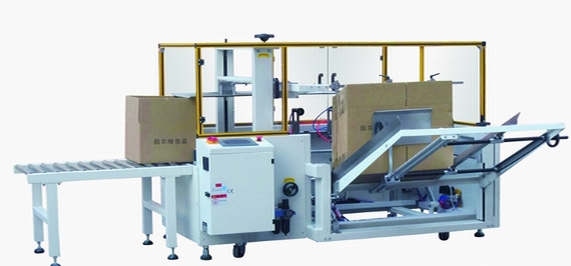
P.10
4）The main menu. (P.11)
Auto/ manual: to switch the auto interface or manual interface. Under the manual interface , press the “start” button to switch to the manual menu.
Counting：Showing the Quantity of forming cases. Push Zero can clear the record.
Erecting Continually：Start this function when you run the machine automatically, then the machine erecting continually.
Erect one case ：Only form and seal one case.
Setting Out-Put ：Showing the quantity of forming case. When you Push RST, the current Out-put becomes Zero. You can clear the Out-put to Zero in the High Level setting.

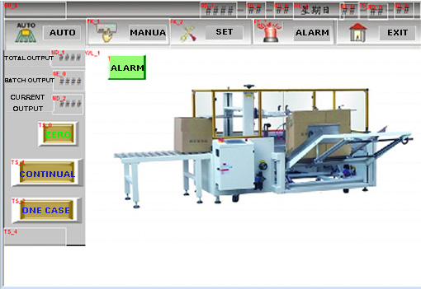
PIC 11
5）Operate the machine manually according to the following picture 12:
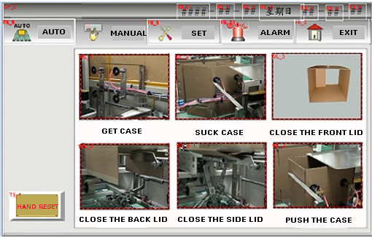
PIC12
6）Set the Touch Scream 。
Basic setting, showing as Picture 13:
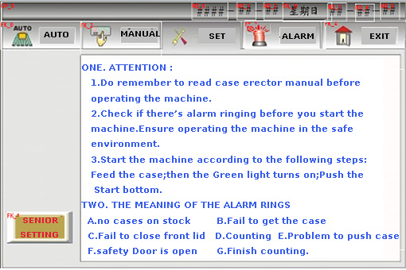
PIC13
High Level Setting showing as Picture14:
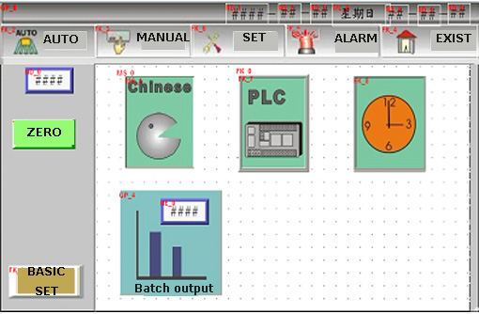
PIC14
1、Click the first Icon to change the language.
2、Click PLC, goes into IO/Input&output as the following picture15.
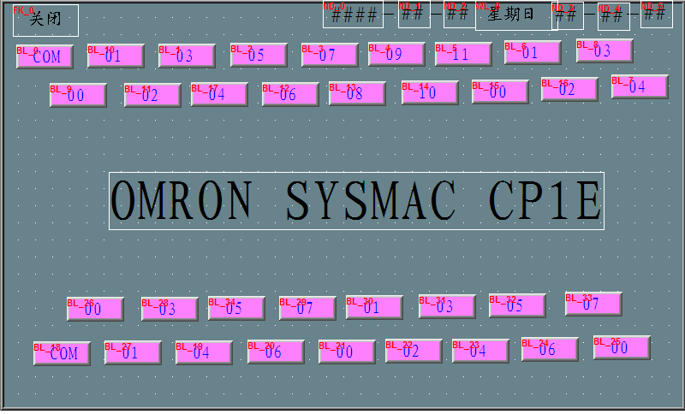
PIC15
3、Click TIME to go and set time as the following Picture16 shows:
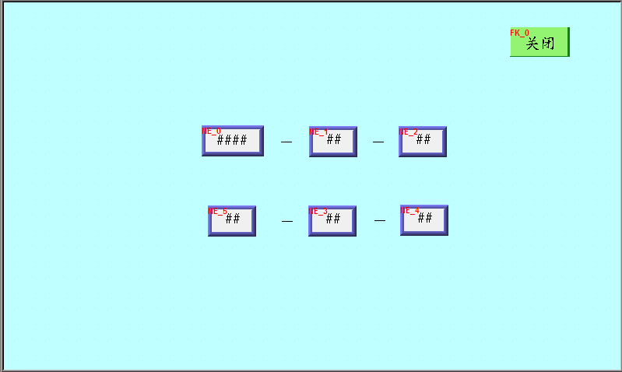
PIC16
4、Click BATCH OUT-PUT to set out-put as the following picture shows:
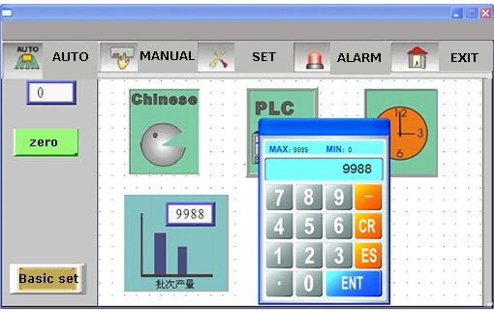
PIC17
8）Alarm rings to tell you information showing as the following picture:
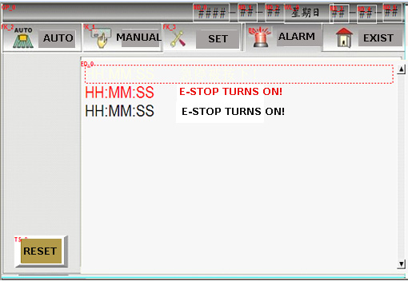
PIC18
3.3Pneumatic Parts Instruction
1）Air-Pressure Drawing showing as the following picture shows:
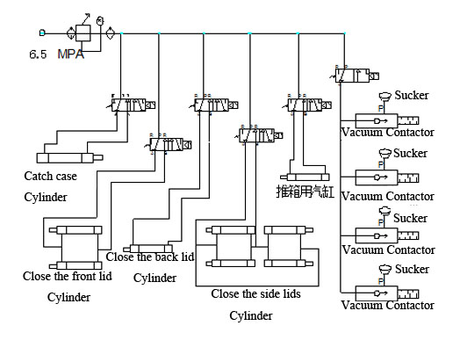PIC19
- It’s important to keep the Air pipes clean and do maintainance anytime.
- Please keep offering the air-pressure at 5～6kg/c㎡ to ensure the machine runs stably.
- Cylinder Container: Keep the shaft clean, otherwise it causes air-leakage when the dust goes into the Piston.
- Maintainance on Air-Pipe: Remember to check if the air-pipe fluent and not blocked for folded. If it happens, please clear and make the air-pipe fluent for the air running.
- Suckers: Keep the suckers clean and far away from the oil. It’s better to clean the Vacuum Contactor every week.
- The Three Points:
- Check if there’s enough oil in it, if not, add some in time. Please use the oil that is only for air-pressure, not too strong;
*Donot use the other oil instead, otherwise it causes air-flow-back, air-blocked and other problems;
2、Check the cup for water and drain away the water when it is too much inside；
3、Set the air-pressure to 5～6kg/c㎡.
H、When stop and do maitainance, please deflate the air by the Pressure release valve in case it does damage for operators.
2）Electronic Drawing showing in the following Picture 20
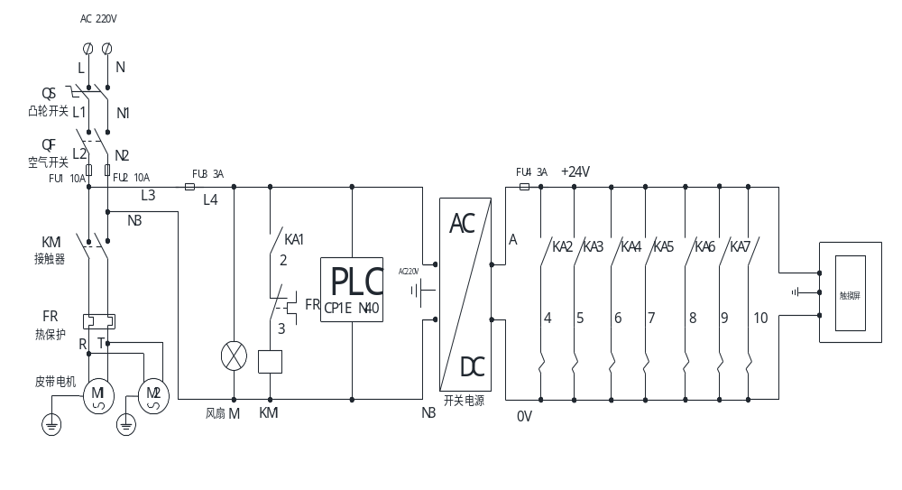PIC20
3）PLC I/O Showing As The Following Picture 21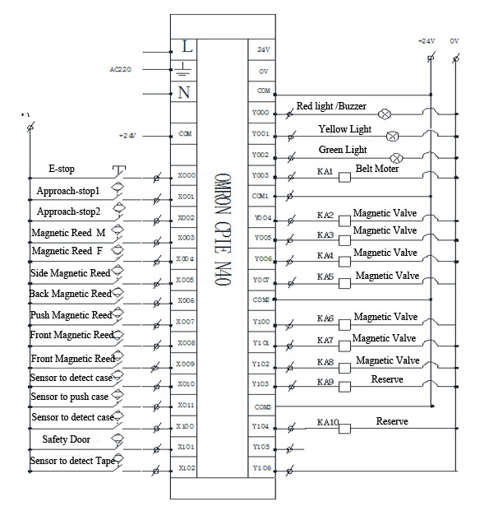
PIC21
3.4 Tape Head’s operating and Maintainance Showing As The Following Picture22:
1、Firstly, load the OPP tape on the tape holder showing as the following picture. Secondly, load the tape goes through the roller C and Roller B. Thirdly, it goes through Roller D. At last it goes out from Roller F after it comes out from the Tape Holder E as the picture shows. Pay attention that the sticky surface should be on the top.
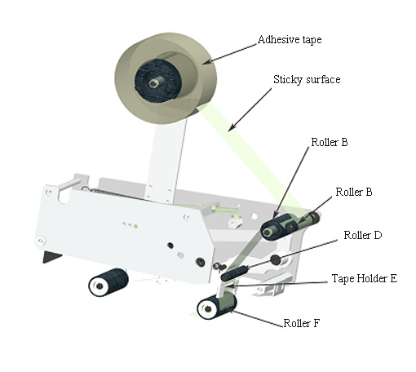
PIC22
2、Adhesive Tape Loading Clue Drawing shows as the following picture23:
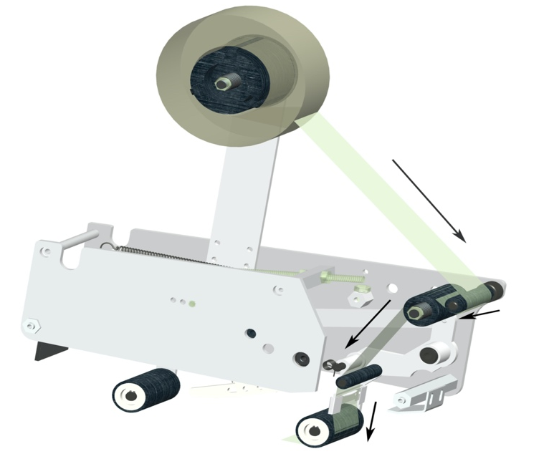
PIC23
3、Adhesive Tape Position Adjusting Shows As The Following Picture24:
If the tape doesn’t stick on the middle of the carton lids, please do a little adjustment according the following pictures: Loosen Nut B, then use the Screw Driver to adjust the center Shaft of the tape holder.
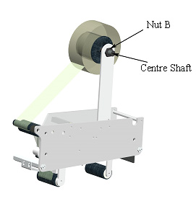
PIC24

4、Tape Tension Adjustment Shows As The Following Picture 25:
Spin the the spinning bottom to a proper speed for the tape, then loosen Nut M8, Adjust the distance between Nut M8*50’s front and back. Change the tension of the Shaft spring to control the Tape’s tension. Spin the spinning bottom clockwise, the tape tension becomes larger, do it in the opposite direction, it becomes smaller. When you make Nut M8*50 go a little front, the tape tension becomes larger, if make it go a little back, it becomes smaller.
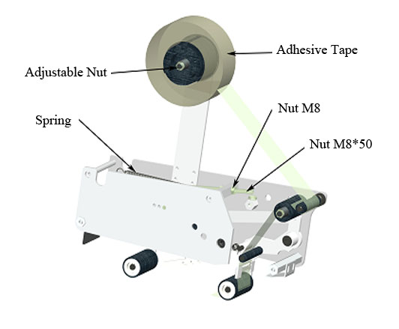
P.25
Tape head malfunctions and solutions

Malfunction | Possible reason | Solution
Adhesive tape can not be cut off | The cutter is not sharp enough.  The cutter tine is jammed by the bond. | Change the cutter  Launder and lubricate the cutter
There is tail after the adhesive tape is cut off. | cutter seat is jammed ,operation is not flexible ,or the spring is not tight enough | check all nuts on the tape head or adjust the spring tension
The adhesive tape can’t stick to the carton completely. | main spring is too loose to keep consistent for speed of rear wheel rebound and belt | lock and tight the main spring nut properly
The carton is locked in the midway. | main spring is too tight, the front wheel is locked in midway | loosen the main spring properly
adhesive tape fall off easily | one-way knurling wheel does not work | change the knurling wheel
carton is crooked and one carton flap is jut compared with the other after sealing |  | the flap edge should parallel the carton body before sealing
there is drape after sealing on tape |  | adjust the nut M8 on the head tape to enlarge the tension as P.26
tape alarm | If missing tape alarm message appears first check your tape head for tape. Image. 0092 | Reset alarm as shown in image. 0093. Then reset solenoid valve as shown in image. 0094.  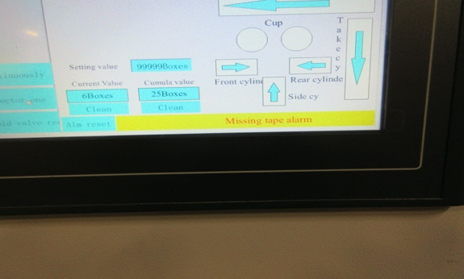  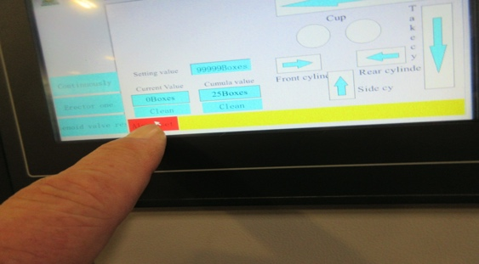  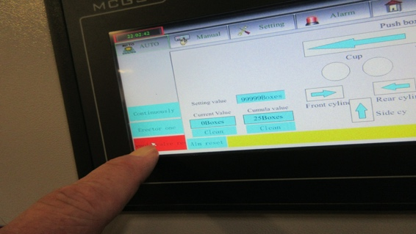

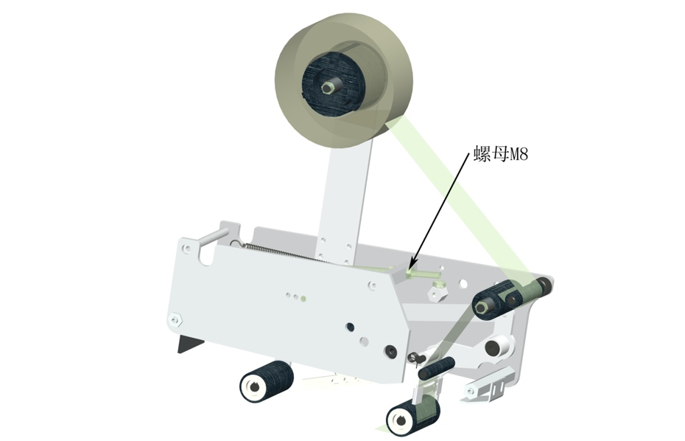

P.26

4 Exploded figure
4.1 each device figure of main body as P.27,T1： 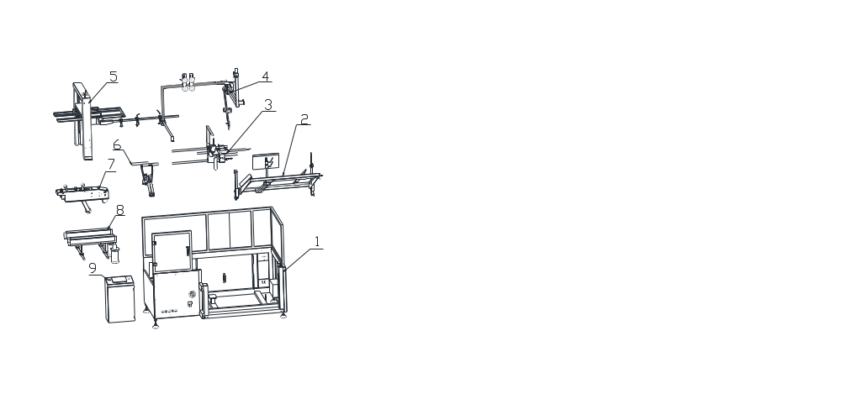P. 27
Part list T.1
NO | Part No. | Part Name | Qty | Remarks
1 | GPK4001 | main machine frame | 1
2 | GPK4002 | store chute device | 1
3 | GPK4003 | rear cover folding and carton pushing device | 1
4 | GPK4004 | carton fetching device | 1
5 | GPK4005 | adjusting device | 1
6 | GPK4006 | side cover folding device | 1
7 | GPK4007 | front cover folding and carton sealing device | 1
8 | GPK4008 | belt conveying device | 1
9 | GPK4009 | electric cabinet | 1
4.2 Main machine frame and electric cabinet figure as P.28, T2.
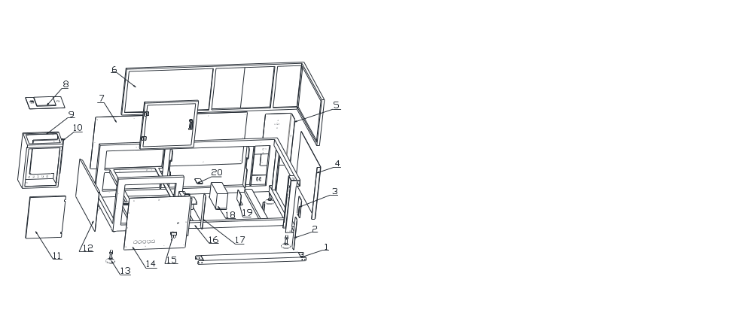 P.28
Part list T.2
NO. | Part No. | Part Name | Qty | Remarks
1 | GPK40101 | connecting chute plate | 1
2 | GPK40102 | right standing pillar bottom sealing plate | 1
3 | GPK40103 | right standing pillar up sealing plate | 1
4 | GPK40104 | right sealing plate | 1
5 | GPK40105 | corner sealing plate | 1
6 | GPK40106 | glass guard | 1
7 | GPK40107 | rear sealing plate | 1
8 | GPK40108 | control panel | 1
9 | GPK40109 | electric cabinet | 1
10 | GPK40110 | switch panel | 1
11 | GPK40111 | electric cabinet cover | 1
12 | GPK40112 | left sealing plate | 1
13 | GPK40113 | bun foot | 4
14 | GPK40114 | front sealing plate | 1
15 |  | air filter | 1
16 | GPK40115 | main machine frame | 1
17 | GPK40116 | left standing pillar bottom sealing plate | 1
18 | GPK40117 | rolling cover plate | 1
19 | GPK40118 | flowing stationary plate | 1
20 | GPK40119 | cover board | 1
4.3 Store chute device figure as P.29,T3
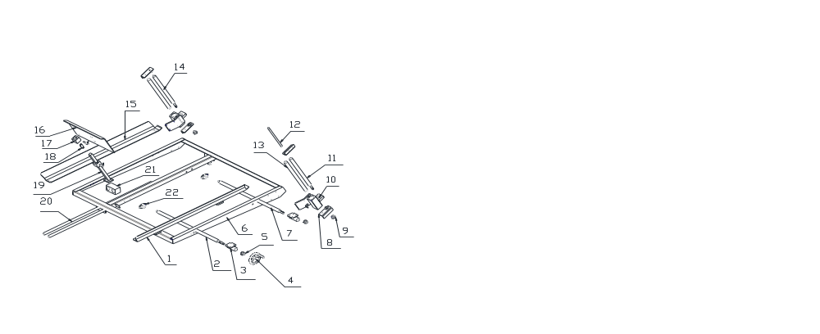 P. 29

Part list T.3
NO | Part No. | Part Name | Qty | Remarks
1 | GPK40201 | activity guide plate | 1
2 | GPK40202 | store chute left and right threaded rod (front) | 1
3 | GPK40203 | store chute left and right tooth tube | 2
4 | GPK40204 | hand wheel | 1
5 | GPK40205 | 1 chain wheel 1 | 2
6 | GPK40206 | store chute main frame | 1
7 | GPK40207 | store chute left and right threaded rod(rear) | 1
8 | GPK40208 | standing pillar angle iron | 4
9 | GPK40209 | 2 chain wheel 2 | 2
10 | GPK40210 | store chute lifting tooth tube | 2
11 | GPK40211 | store chute lifting short threaded rod | 1
12 | GPK40212 | store chute lifting threaded rod extension shaft | 1
13 | GPK40213 | Store chute lifting guide shaft | 2
14 | GPK40214 | store chute lifting long threaded rod | 1
15 | GPK40215 | stationary guide plate | 1
16 | GPK40216 | pressure plate | 1
17 | GPK40217 | connecting square tube | 2
18 | GPK40218 | U type adjusting spacer | 1
19 | GPK40219 | supporting bar | 1
20 | GPK40220 | pressure guide bar | 2
21 | GPK40221 | store chute slider | 1
22 | GPK40222 | seat bearing | 4

4.4 rear cover folding and carton pushing device figure as P.30,T4

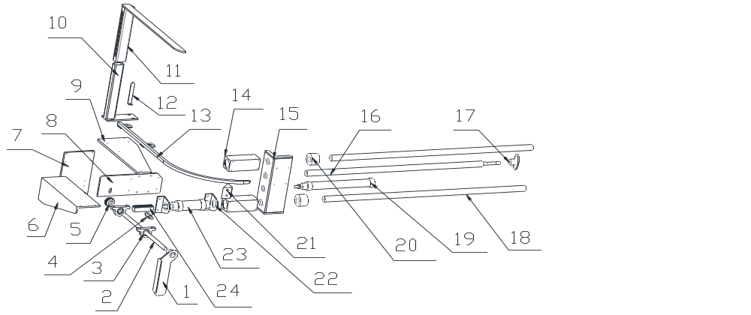图三十
Part list T.4
NO. | Part No. | Part Name | Qty | Remarks
1 | GPK40301 | rear cover folding set piece | 1
2 | GPK40302 | rear cover folding shaft | 1
3 | GPK40303 | seat bearing | 2
4 | GPK40304 | rack roller carrier shaft | 1
5 | GPK40305 | gear | 1
6 | GPK40306 | rear cover folding supporting plate | 1
7 | GPK40307 | slider connecting plate | 1
8 | GPK40308 | rear cover folding supporting plate 2 | 1
9 | GPK40309 | supporting plate | 1
10 | GPK40310 | pushing bar supporting tube | 1
11 | GPK40311 | pushing bar | 1
12 | GPK40312 | indicator | 1
13 | GPK40313 | radial block | 1
14 | GPK40314 | carton fetching slider | 1
15 | GPK40315 | carton pushing seat | 1
16 | GPK40316 | adjusting silk pole | 1
17 | GPK40317 | prismatic locking block | 1
18 | GPK40318 | carton pushing sliding shaft | 1
19 | PC32B200 | carton pushing cylinder | 1
20 | GPK40319 | guide bar shaft sleeve | 2
21 | GPK40220 | carton pushing cylinder seat | 1
22 | GPK40221 | front cover folding cylinder seat | 2
23 | PC40B30 | front cover folding cylinder | 1
24 | GPK40222 | rack | 1
4.5 carton fetching device figure as P.31,T.5
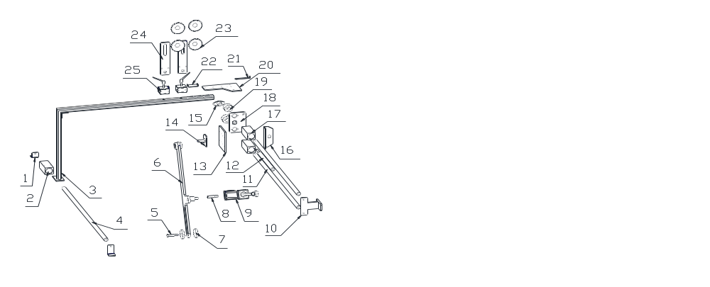P.31
零件表Part list T.5
NO. | Part No. | Part Name | Qty | Remarks
1 | GPK40401 | （1，2）holder(1,2) | 2
2 | GPK40402 | auxiliary rod slider | 1
3 | GPK40403 | auxiliary rod | 1
4 | GPK40404 | auxiliary rod shaft | 1
5 | GPK40405 | carton fetching swinging rod connecting shaft | 1
6 | GPK40406 | carton fetching swinging rod | 1
7 | GPK40407 | nylon pad | 2
8 | GPK40408 | carton fetching cylinder connecting shaft | 1
9 | TC50B250 | carton fetching cylinder | 1
10 | GPK40409 | supporting seat | 1
11 | GPK40410 | carton fetching slider supporting shaft | 2
12 | GPK40411 | carton fetching adjusting silk shaft | 1
13 | GPK40412 | slider connecting plate | 1
14 | GPK40413 | stir shaft plate | 1
15 | GPK40414 | prismatic locking block | 1
16 | GPK40415 | buffer angle iron | 1
17 | GPK40416 | carton fetching slider | 2
18 | GPK40417 | adjusting nut plate | 1
19 | GPK40418 | shaft sleeve | 2
20 | GPK40419 | auxiliary slider shaft connecting plate | 1
21 | GPK40420 | position adjustment indicator | 1
22 | GPK40421 | U type spacer | 2
23 | GPK40422 | suction cup | 4
24 | GPK40423 | suction cup stationary plate | 2
25 | GPK40424 | positioning square tube | 2

4.6。adjusting device figure as P.32,T6
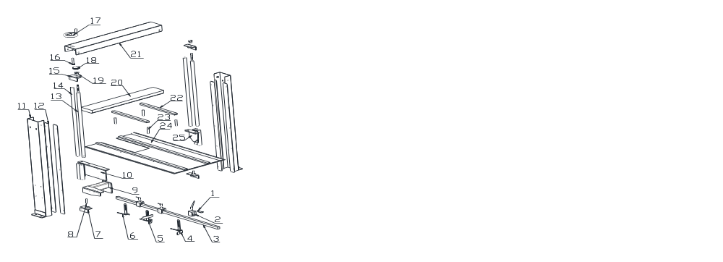P.32
Part list T.6
NO. | Part No. | Part Name | Qty | Remarks
1 | GPK40501 | U type spacer | 3
2 | GPK40502 | positioning square tube | 3
3 | GPK40503 | cantilever | 1
4 | GPK40504 | right adjusting block | 1
5 | GPK40505 | middle adjusting block | 1
6 | GPK40506 | left adjusting block | 1
7 | GPK40507 | 1 bearing seat 1 | 2
8 | GPK40508 | lifting threaded rod extension shaft | 2
9 | GPK40509 | supporting angle iron | 1
10 | GPK40510 | inner side supporting seat | 1

11 | GPK40511 | Adjusting pillar | 2
12 | GPK40512 | Cover | 4
13 | GPK40513 | Lead screw | 2
14 | GPK40514 | Slide support shaft | 2
15 | GPK40515 | Supporting seat 2 | 2
16 | GPK40516 | Gear shaft | 1
17 | GPK40517 | Hand wheel | 1
18 | GPK40518 | Big gear | 1
19 | GPK40519 | Chain wheel | 1
20 | GPK40520 | Adjusting beam | 1
21 | GPK40521 | Chain cover | 1
22 | GPK40522 | Fixing board | 2
23 | GPK40523 | Adjusting slide shaft | 4
24 | GPK40524 | Top board | 1
25 | GPK40525 | Side support seat | 1
4.7 Side Flaps Folding Device, Image 33, Chart 7.

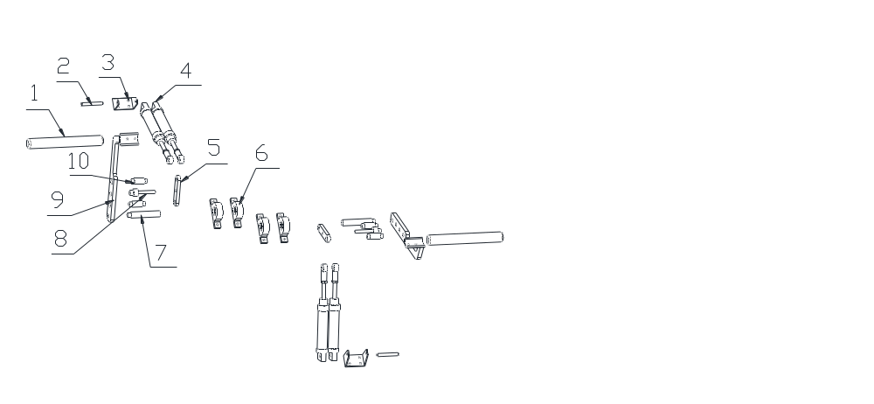Image 33

Spares list Chart 7
Item | Parts No. | Name | Qty | Memo
1 | GPK40601 | Driving lever | 2
2 | GPK40602 | Cylinder locking shaft | 2
3 | GPK40603 | Cylinder fixing seat | 2
4 | PC32B80 | Side flaps folding cylinder | 4
5 | GPK40604 | Joint board | 2
6 | GPK40605 | Bearing with seat | 4
7 | GPK40606 | Swing rod locating shaft | 2
8 | GPK40607 | Joint shaft | 2
9 | GPK40608 | Swing rod | 2
10 | GPK40609 | Pin type shaft | 4
4.8 Front flap folding and taping part, Image 34, Chart 8:
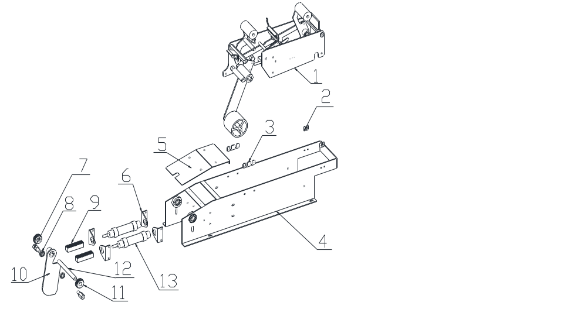 Image 34
Spares list Chart 8
Item | Parts No. | Name | Qty | Memo
1 | GPK40701 | Tape head | 1
2 | GPK40702 | Joint plate 1 | 2
3 | GPK40703 | Joint plate 2 | 2
4 | GPK40704 | Support bracket | 1
5 | GPK40705 | Cover plate | 1
6 | GPK40706 | Cylinder seat | 4
7 | GPK40707 | Gear rack shaft | 2
8 | GPK40708 | Bearing | 2
9 | GPK40709 | Gear rack | 2
10 | GPK40710 | Driving block | 1
11 | GPK40711 | Wheel gear | 2
12 | GPK40712 | Flap folding shaft | 1
13 | DSC320B30 | Cylinder | 2
4.9 Tape Head Part, Image 35, Chart 9。
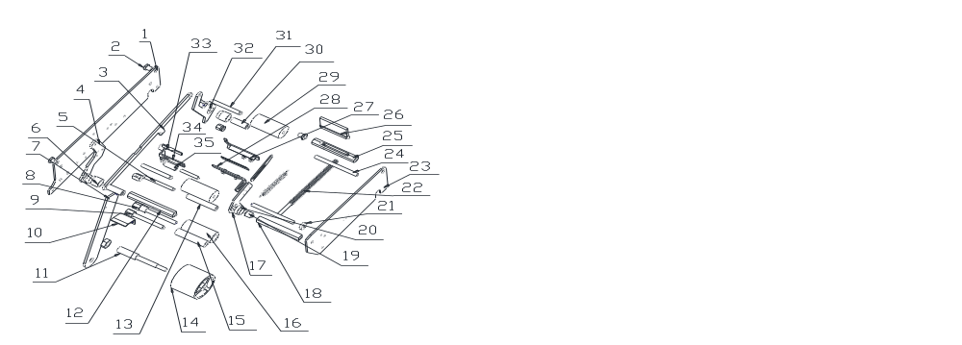Image 35
Spares list Chart 9
Item | Parts No. | Name | Qty | Memo
1 | GPK40801 | Left plate | 1
2 | GPK40802 | Hexagon shaft | 1
3 | GPK40803 | Joint rod | 1
4 | GPK40804 | Backswing | 1
5 | GPK40805 | Knurl wheel shaft | 1
6 | GPK40806 | Fix shaft sleeve | 2
7 | GPK40807 | Tape support piece | 1
8 | GPK40808 | Guide wheel shaft | 1
9 | GPK40809 | PE tape guide shaft | 1
10 | GPK40810 | Front guide board | 1
11 | GPK40811 | Tape seat fix shaft | 1
12 | GPK40812 | Front pivot axis | 1
13 | GPK40813 | Knurl guide wheel | 1
14 | GPK40814 | Tape wheel | 1
15 | GPK40815 | PE tape guide wheel | 1
16 | GPK40816 | One-way knurl wheel | 1
17 | GPK40817 | Cutter soldering block | 1
18 | GPK40818 | Spring locking shaft | 1
19 | GPK40819 | Cutter seat fix shaft | 1
20 | GPK40820 | Fix shaft sleeve | 1
21 | GPK40821 | Blocking wheel | 2
22 | GPK40822 | Main spring | 1
23 | GPK40823 | Right plate | 1
24 | GPK40824 | Plate locking shaft | 2
25 | GPK40825 | Brush locking shaft | 1
26 | GPK40826 | Brush | 1
27 | GPK40827 | Cutter cover | 1
28 | GPK40828 | Bracket | 1
29 | GPK40829 | Taping wheel | 2
30 | GPK40830 | Swinging fix shaft | 2
31 | GPK40831 | Taping wheel shaft | 2
32 | GPK40832 | Backswing | 1
33 | GPK40833 | Tape top piece | 1
34 | GPK40834 | Tape bracket | 1
35 | GPK40835 | U-shape shaft sleeve | 1
4.10 Belts conveying device, Image 36, Chart 10:
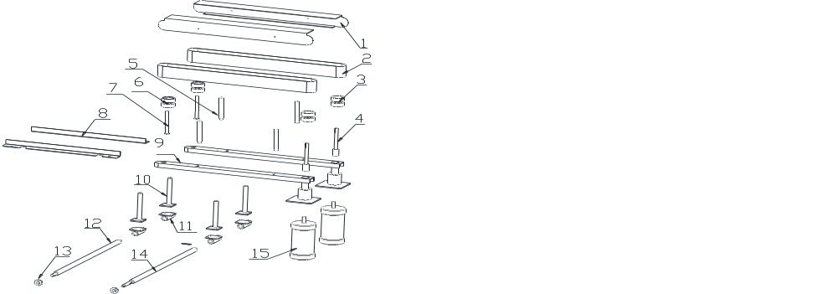Image 36
Spares list Chart 8
Item | Parts No. | Name | Qty | Memo
1 | GPK40901 | Belt cover | 2
2 | GPK40902 | Conveying belt | 2
3 | GPK40903 | Drive wheel | 2
4 | GPK40904 | Drive wheel shaft | 2
5 | GPK40905 | Belt cover support rod | 4
6 | GPK40906 | Driven wheel | 2
7 | GPK40907 | Driven wheel shaft | 2
8 | GPK40908 | belt guide plate | 2
9 | GPK40909 | Belt cover support | 2
10 | GPK40910 | Belt support seat | 4
11 | GPK40911 | Support barrel | 4
12 | GPK40912 | Driven lead screw | 1
13  14 | GPK40913 | Chain wheel | 2
14  15 | GPK40914 | Drive lead screw | 1
15 | GPK40915 | Motor | 2

